1.
Modificar las estructuras de las siguientes tablas:
Agregar/Modificar los campos que están en azul

Structure for table: H:\O-NEGOCIOS\AROMAS\DATA\CIA001\C2006\ALMCTRAN.DBF
Number of data records: 27
Date of last update: 16/11/2006
Memo file block size: 64
Code Page: 1252
Field Field Name Type Width Dec Index Collate Nulls Next Step
1 CODSED Character 3 No
2 SUBALM Character 3 No
3 TIPMOV Character 1 No
4 CODMOV Character 3 No
5 NRODOC Character 10 No
6 FCHDOC Date 8 No
7 ALMTRF Character 3 No
8 ALMORI Character 3 No
9 CODLOTE Character 3 No
10 CODCULT Character 8 No
11 CODFASE Character 3 No
12 CODPROCS Character 3 No
13 CODACTIV Character 3 No
14 TPORF1 Character 4 No
15 NRORF1 Character 10 No
16 TPORF2 Character 4 No
17 NRORF2 Character 10 No
18 TPORF3 Character 4 No
19 NRORF3 Character 10 No
20 NROODT Character 10 No
21 CODPRD Character 8 No
22 CODPRO Character 11 No
23 CODCLI Character 11 No
24 CODDIRE Character 3 No
25 CODVEN Character 4 No
26 CODPAR Character 8 No
27 OBSERV Character 40 No
28 NROITM Numeric 3 No
29 CODMON Numeric 1 No
30 TPOCMB Numeric 14 4 No
31 IMPBRT Numeric 14 2 No
32 FLGEST Character 1 No
33 FLGFAC Character 1 No
34 NROPED Character 6 No
35 TPOCLI Character 2 No
36 PLZVTO Numeric 2 No
37 FMAPGO Numeric 3 No
38 TIPPRC Numeric 1 No
39 IMPDST Numeric 16 2 No
40 IMPIGV Numeric 16 2 No
41 CODOPE Character 2 No
42 IMPTOT Numeric 16 2 No
43 PORIGV Numeric 6 2 No
44 USER Character 10 No
45 FBATCH Numeric 8 4 No
46 CODTRA Character 3 No
47 NOMTRA Memo 4 No
48 DIRTRA Memo 4 No
49 RUCTRA Character 11 No
50 PLATRA Character 10 No
51 MOTIVO Numeric 1 No
52 BREVET Character 20 No
53 CODUSER Character 8 No
54 FCHHORA DateTime 8 No
55 CNDPGO Character 18 No
56 FCHFIN DateTime 8 No
** Total ** 409

Structure for table: H:\O-NEGOCIOS\AROMAS\DATA\CIA001\C2006\ALMDTRAN.DBF
Number of data records: 43
Date of last update: 16/11/2006
Code Page: 1252
Field Field Name Type Width Dec Index Collate Nulls Next Step
1 CODSED Character 3 No
2 SUBALM Character 3 No
3 ALMTRF Character 3 No
4 ALMORI Character 3 No
5 TIPMOV Character 1 No
6 CODMOV Character 3 No
7 NRODOC Character 10 No
8 NROITM Numeric 3 No
9 NRO_ITM Numeric 3 No
10 FCHDOC Date 8 No
11 CODCLI Character 11 No
12 CODPRO Character 11 No
13 CODMON Numeric 1 No
14 TPOCMB Numeric 10 4 No
15 TPOREQ Character 1 No
16 CODMAT Character 13 No
17 DESMAT Character 40 No
18 CODPRD Character 13 Asc Machine No
19 CANDES Numeric 14 4 No
20 CANREC Numeric 14 4 No
21 LOTE Character 15 Asc Machine No
22 FCHVTO Date 8 No
23 CANDEV Numeric 14 4 No
24 CNFMLA Numeric 14 4 No
25 FACTOR Numeric 7 4 No
26 PREUNI Numeric 16 4 No
27 IMPCTO Numeric 14 4 No
28 STKSUB Numeric 16 4 No
29 STKACT Numeric 16 4 No
30 CODAJT Character 1 No
31 UNDVTA Character 3 No
32 TPOREF Character 4 No
33 NROREF Character 10 No
34 TPORFB Character 4 No
35 NRORFB Character 10 No
36 NROREF2 Character 10 No
37 IMPNAC Numeric 16 4 No
38 IMPUSA Numeric 16 4 No
39 VCTOMN Numeric 16 4 No
40 VCTOUS Numeric 16 4 No
41 USER Character 10 No
42 FBATCH Numeric 8 4 No
43 CODOPE Character 3 No
44 NROAST Character 6 No
45 ANOAST Character 4 No
46 CODNEW Character 13 No
47 CODNEW1 Character 8 No
48 CODUSER Character 8 No
49 FCHHORA DateTime 8 No
50 NROREG_1 Numeric 10 No
51 D1 Numeric 5 2 No
52 D2 Numeric 5 2 No
53 D3 Numeric 5 2 No
54 PREC_CIF Numeric 14 4 No
55 FACT_IMP Numeric 10 4 No
56 SITU Character 10 No
57 SERIE Varchar 100 No
** Total ** 623

Structure for table: H:\O-NEGOCIOS\AROMAS\DATA\CIA001\C2006\ALMCFTRA.DBF
Number of data records: 28
Date of last update: 16/11/2006
Memo file block size: 64
Code Page: 1252
Field Field Name Type Width Dec Index Collate Nulls Next Step
1 TIPMOV Character 1 No
2 CODMOV Character 3 No
3 DESMOV Character 37 No
4 PIDRF1 Logical 1 No
5 PIDRF2 Logical 1 No
6 PIDRF3 Logical 1 No
7 GLORF1 Character 16 No
8 GLORF2 Character 16 No
9 GLORF3 Character 16 No
10 PIDVEN Logical 1 No
11 PIDCLI Logical 1 No
12 PIDPRO Logical 1 No
13 PIDODT Logical 1 No
14 PIDACTFIJO Logical 1 No
15 PIDPCO Logical 1 No
16 PIDPVT Logical 1 No
17 MODPRE Logical 1 No
18 STKNEG Logical 1 No
19 UNDSTK Logical 1 No
20 UNDVTA Logical 1 No
21 UNDCMP Logical 1 No
22 MODCSM Logical 1 No
23 EXTPCO Logical 1 No
24 MONNAC Logical 1 No
25 MONUSA Logical 1 No
26 MONELG Logical 1 No
27 TRANSF Logical 1 No
28 MOVPRO Numeric 1 No
29 CMPEVA Character 30 No
30 EVALUA Memo 4 No
31 PORP_T Logical 1 No
32 CMPACT1 Character 10 No
33 CMPACT2 Character 10 No
34 CMPACT3 Character 10 No
35 ORDPRO Character 2 No
36 ORDEN Character 3 Asc Machine No
37 TPORF1 Character 4 No
38 TPORF2 Character 4 No
39 TPORF3 Character 4 No
40 CORR_U Logical 1 No
41 VALCTB Logical 1 No
42 AFETRA Logical 1 No
43 PIDLOTE Logical 1 No
44 PIDPROCESO Logical 1 No
45 PIDACTIVID Logical 1 No
46 PIDCULTIVO Logical 1 No
47 PIDFASE Logical 1 No
48 CODUSER Character 8 No
49 FCHHORA DateTime 8 No
50 CTOVTA Logical 1 No
51 PIDMOT Logical 1 No
52 ES_IMP Logical 1 No
53 PIDUNC1 Logical 1 No
54 PIDUNC2 Logical 1 No
55 PIDUNC3 Logical 1 No
56 GLOUNC1 Character 16 No
57 GLOUNC2 Character 16 No
58 GLOUNC3 Character 16 No
59 UNDUNC1 Character 1 No
60 UNDUNC2 Character 1 No
61 UNDUNC3 Character 1 No
62 LONUNC1 Numeric 3 1 No
63 LONUNC2 Numeric 3 1 No
64 LONUNC3 Numeric 3 1 No
65 PIDLOTEITM Logical 1 No
66 PIDSERIITM Logical 1 No
67 PIDVTOITM Logical 1 No
68 GLOLOTEITM Character 16 No
69 GLOSERIITM Character 16 No
70 GLOVTOITM Character 16 No
71 PIDFCHFIN Logical 1 No
72 GLOFCHFIN Character 16 No
73 PIDSITUITM Logical 1 No
74 GLOSITUITM Character 16 No
** Total ** 369

Para modificar las estructuras te posicionas en la ruta de la tabla y abres el VFP o abres el VFP y en la ventana de comando pones por ejemplo:

SET DEFA TO H:\O-NEGOCIOS\AROMAS\DATA\CIA001\C2006\
Use almctran excl
Modi stru

Y haces los cambios como se hizo la vez anterior.
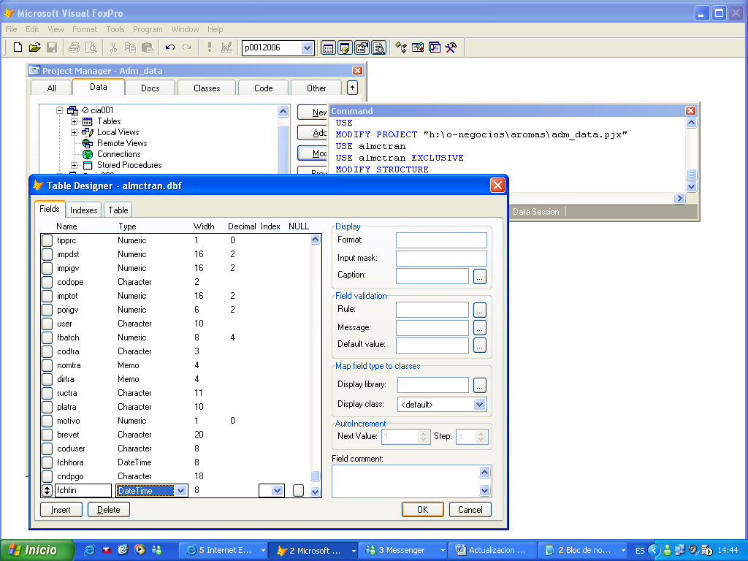

2.
Adicionalmente,
Hay que añadir la siguiente tabla ALMDSERI la cual te la estoy adjuntado en el mail en un almdseri.zip, lo desempaquetas en la ruta H:\O-NEGOCIOS\AROMAS\DATA\CIA001\C2006\
Y como la vez anterior te vas al VFP y abres el proyecto H:\O-NEGOCIOS\AROMAS\ADM_DATA.pjx

Te vas a la pestaña DATA y agregas la tabla almdseri que estara en la ruta H:\O-NEGOCIOS\AROMAS\DATA\CIA001\C2006\

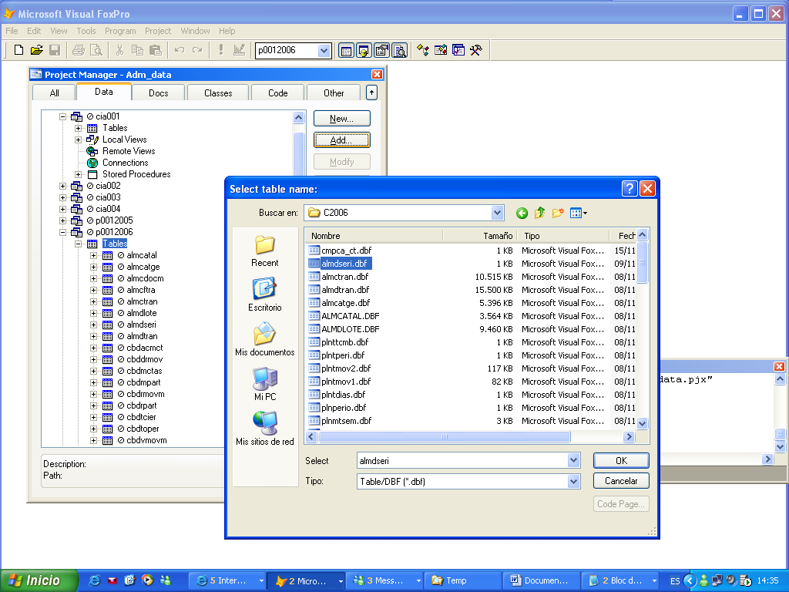

NOTA:
Para modificar las estructuras necesitas de las tablas indicadas se necesita abrir en exclusivo las tablas y como son usadas por almacén y facturación tendrá que hacerse cuando los usuarios no estén en el sistema.

